Mix Bag

Q1)
a. RYBR Inc., an all-equity firm, has net income of $100 million currently and expects this number to grow at 10% a year for the next three years. The firm's working capital increased by $10 million this year and is expected to increase by the same dollar amount each of the next three years. The depreciation is $50 million and is expected to grow 8% a year for the next three years.
Finally, the firm plans to invest $60 million in capital expenditure for each of the next three years. The firm pays 60% of its earnings as dividends each year. RYBR has a cash balance currently of $50. Assuming that the cash does not earn any interest, how much would you expect to have as a cash balance at the end of the third year?

b. Assume that RYBR had financed 20% of its reinvestment needs with debt, estimate the cash balance at the end of the third year.

c. Now assume that stockholders in RYBR are primarily corporations. They are exempt from ordinary taxes on 85% of the dividends that they receive (Ordinary tax rate=30%) and pay capital gains on price appreciation at a 20% rate. If RYBR pays a dividend of $2 per share, how much would you expect the stock price change to be on the ex-dividend date?

Q2) Solo Corporation, a manufacturer of surf boards, has asked for your advice on whether to invest $ 40 million in a new line of beach products:
• The investment will yield earnings before interest and taxes of $ 10 million a year, and any depreciation on the project will be invested back into the project as capital maintenance expenditure. There will be no working capital investments.
• The project is expected to have an infinite life.
• The company has a beta of 1.2, but this project is expected to have a beta of 1.5. The firm will maintain its existing financing mix of 60% equity and 40% debt. The cost of borrowing is 10%.
• The tax rate for the company, including state taxes, is 40%. The ten-year bond rate is 7%.
Calculate the NPV of this project.

Q3) If the company currently has a cash balance of $50 million, estimate the cash balance at the end of year 3.
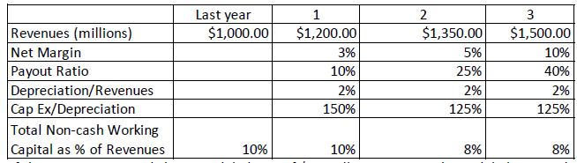

Q4) Varitek inc is a publicly traded company that generated $ 80 million in after tax operating income in the most recent year, on invested capital of $500 million. The company had capital expenditures of $60 million, depreciation of $30 million and saw non-cash working capital increase from $60 million to $80 million in the most recent year. If this company can maintain its return on capital and reinvestment rate for the next three years, and that the
expected growth rate will drop to 2.5% after year 3 (with return on capital staying at current levels), estimate the value of the operating assets today. (The cost of capital is 9% for the next three years and 7.5% thereafter.)

Q5) You work for a Genome Drugs, small biotechnology company that has a 10-year patent for a drug that it plans to license to a larger pharmaceutical company and it has two offers:
• Biogen has offered to pay $100 million today and $50 million a year, each
year for the next 5 years.
• Merck has offered to pay $50 million today and share 15% of net income,
expected to be $400 million annually, each year for the next 10 years.
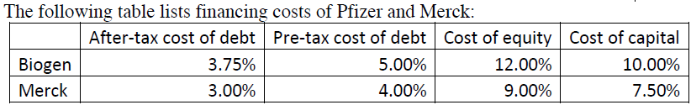
Which offer would create more value for you?

Q6) Conway Inc. has 125 million shares, trading at $8/share, no debt and a cost of equity of 9%. You believe that if the company can borrow $400 million and buy back shares, the cost of capital will drop to 8%. If there is no growth in the savings (from a lower cost of capital) and the shares are bought back at $10/share, estimate the value per share for the remaining shares after the buyback.

Q7. A company is currently selling 100,000 units of its product at Rs 50 each unit. At the current level of production, the cost per unit is Rs 45, variable cost per unit is Rs 40. The company is currently extending one month’s credit to its customers. It is thinking of extending credit period to two months in that sales expectation will increase by 25%. If required rate of return (before-tax) on firm’s investment is 30%, is the new credit policy desirable?

Q8.
A company currently has annual sales of Rs. 500,000 and an average collection period of 30 days. It is considering a more liberal credit policy. If the credit period is extended, the company expects sales and bad-debt losses to increase in following manner

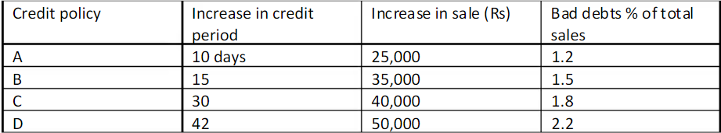

The selling price per unit is Rs 2. Average cost per unit at the current level of operations is Rs. 1.50 and variable cost per unit is Rs. 1.20. if current bad debt loss is 1% and required rate of return on investment is 20%, which credit policy should be undertaken? Ignore taxes and assume 360 days in a year.

